# Introduction

The purpose of this document is to validate whether the CampusNexus Engage application is setup and running correctly on a Dynamics Organization. The target audience for this document is the Implementation/Deployment team.

# Pre-Install Checklist (Mandatory)

|  |  |  |
| --- | --- | --- |
| **Sl. No.** | **Activity** | **Status** |
| **1** | **Ensure adequate Dynamics 365 user licenses are available along with Deployment Tools** |  |
| **2** | **Ensure Azure subscription is available to allow hosting of Azure functions** |  |
| **3** | **Ensure all the required components listed below are deployed on the organization with appropriate licenses as applicable** |  |
| 3.1 | * CafeX |  |
| 3.2 | * Marketing 2.0 ( including "Voice of the Customer") |  |
| 3.3 | * Power BI |  |
| 3.4 | * Portal (If more than one Customer Self Service Portal is required, additional licenses need to be procured) |  |
| **4** | **BingMap API key with valid license must be procured** |  |
| **5** | **Login to the Dynamics Organization and verify that the above features are available** |  |
| **6** | **Ensure you have access to the below managed solutions** |  |
| 6.1 | * Campus Management |  |
| 6.2 | * Campus Management Extended |  |
| 6.3 | * Power BI Integration |  |
| **7** | **Ensure the below files are available for import during Deployment** |  |
| 7.1 | Default Data (To be imported using **SonomaPartners.Xrm.DefaultData.WPF**.**exe**) |  |
| 7.2 | Filtered Data (To be imported using **FilteredDefaultData.ps1**) |  |
| 7.3 | Portal Pages (To be imported using **MovePortal.ps1**) |  |
| 7.4 | Copy Survey (To be imported using **MoveSurveys.ps1**) |  |

# Post-Install Checklist (Mandatory)

|  |  |  |
| --- | --- | --- |
| **Sl. No.** | **Activity** | **Status** |
| **1** | **Verify Deployment** |  |
|  | Validate the deployment logs and make sure there are no errors |  |
|  |  |  |
| **2** | **Validate Customizations** |  |
| 2.1 | Check if the below solutions are installed with the correct version |  |
|  | •         Campus Management – 0.6.0.101 |  |
|  | •         Campus Management Extended – 0.6.0.101 |  |
|  | •         Power BI Integration – 0.6.0.101 |  |
| 2.2 | Check if the 4 plugin dlls are registered and all the Plugin steps are enabled |  |
|  | •         Cmc.Engage.Common.Plugins |
|  | •         Cmc.Engage.Communication.Plugins |
|  | •         Cmc.Engage.Lifecycle.Plugins |
|  | •         Cmc.Engage.Retention.Plugins |
| 2.3 | Check if the 3 activity dlls are registered and enabled |  |
|  | •         Cmc.Engage.Common.Activities |
|  | •         Cmc.Engage.Communication.Activities |
|  | •         Cmc.Engage.Lifecycle.Activities |
| 2.4 | Check all the Business Rules are present and in active state |  |
| 2.5 | Check all the Actions, Business Process Flows, Custom Workflows are present and activated |  |
|  |  |  |
| **3** | **Validate Additional Configurations** |  |
| 3.1 | Validate the System Time Zone settings, Format settings under **Settings > Administration > System Settings > Format** is set correctly |  |
| 3.2 | * Email Configurations under Navigate to **Settings > Email configuration > Email Configuration Settings** are correct * Mailboxes under **Settings > Email configuration > Mailboxes** are enabled and the Configuration Test Results for all the Mailboxes are Success for Incoming Email Status, Outgoing Email Status and Appointments, Contacts, and Tasks Status |  |
|  |  |  |
| **4** | **Portal Configuration** |  |
| 4.1 | Authentication Configuration |  |
| 4.2 | Login |  |
| 4.3 | Web Pages |  |
|  |  |  |
| **5** | **Chat & Co-Browse configuration** |  |
|  |  |  |
| **6** | **PowerBI configuration** |  |
|  | Configure Retention Dashboard |  |
|  |  |  |
| **7** | **Verifications** |  |
| 7.1 | Verify Azure function settings are correct |  |
| 7.2 | Verify the Configuration Key settings |  |
| 7.3 | Ensure TraceLogLevel is set to None or Exception to avoid performance impact |  |
| 7.4 | Ensure Report Scripting Errors Preference is turned off |  |

## Business Rules

Verify in all the below pages with data should be available:

Navigate to Solutions > Campus Management > Entity > DOM Definition Logic > Business Rules

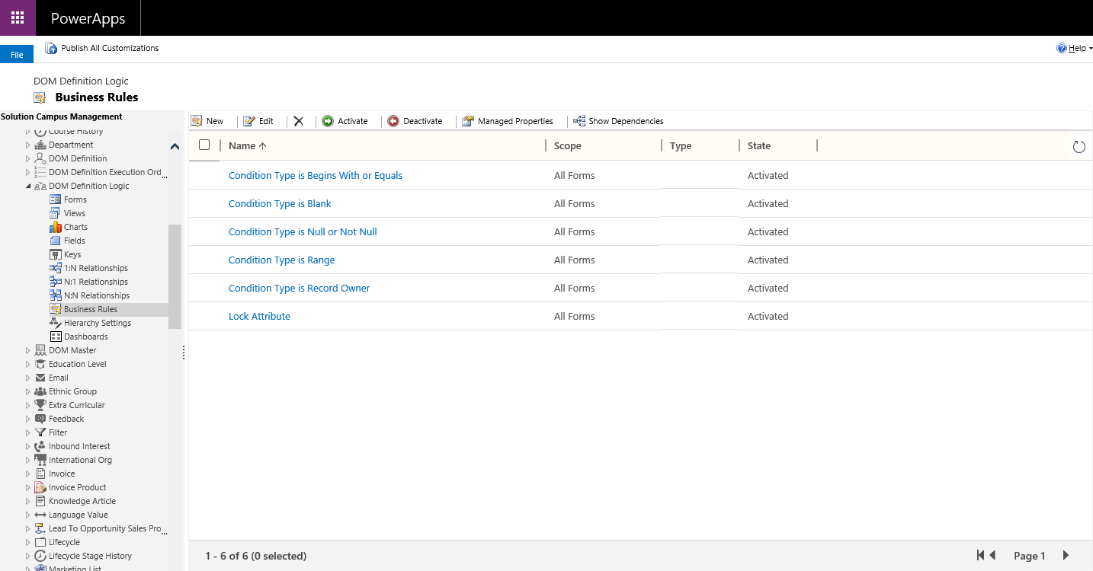

Navigate to Solutions > Campus Management > Entity > DOM Master > Business Rules

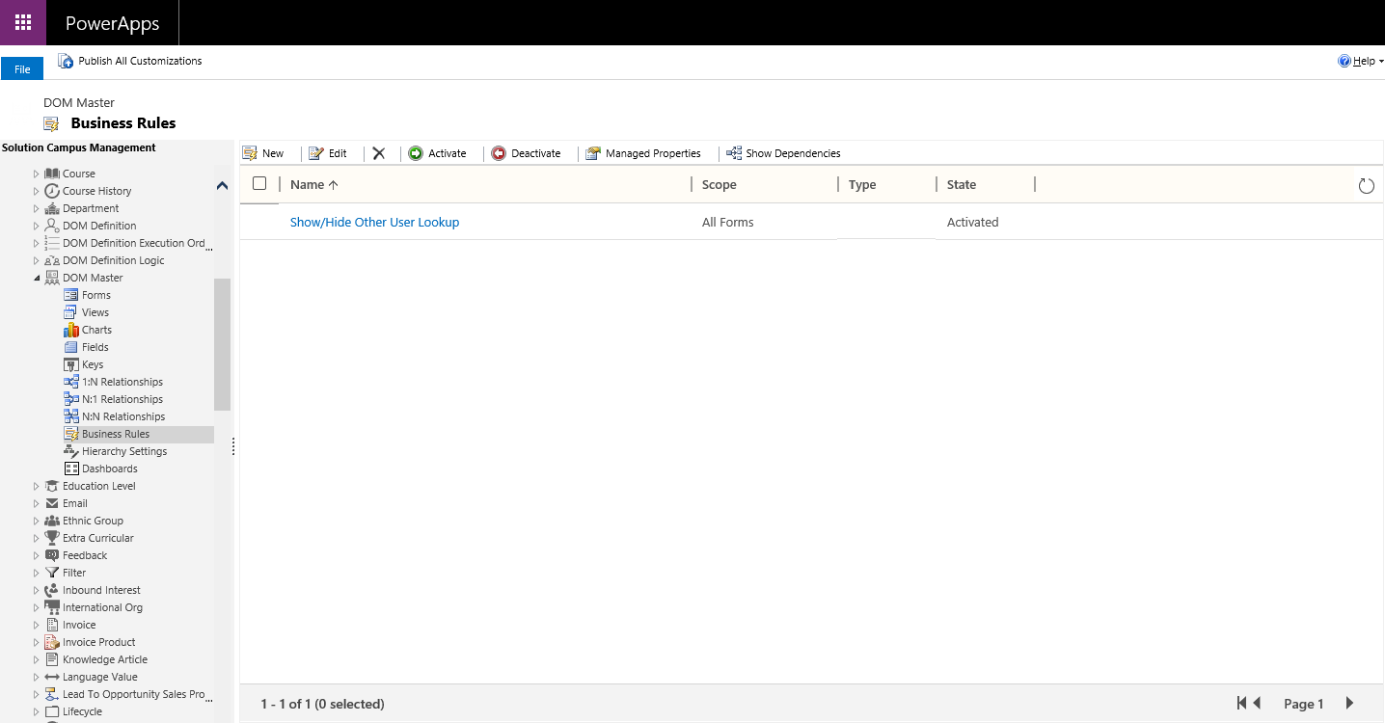

Navigate to Solutions > Campus Management > Entity > Staff Survey Template > Business Rules

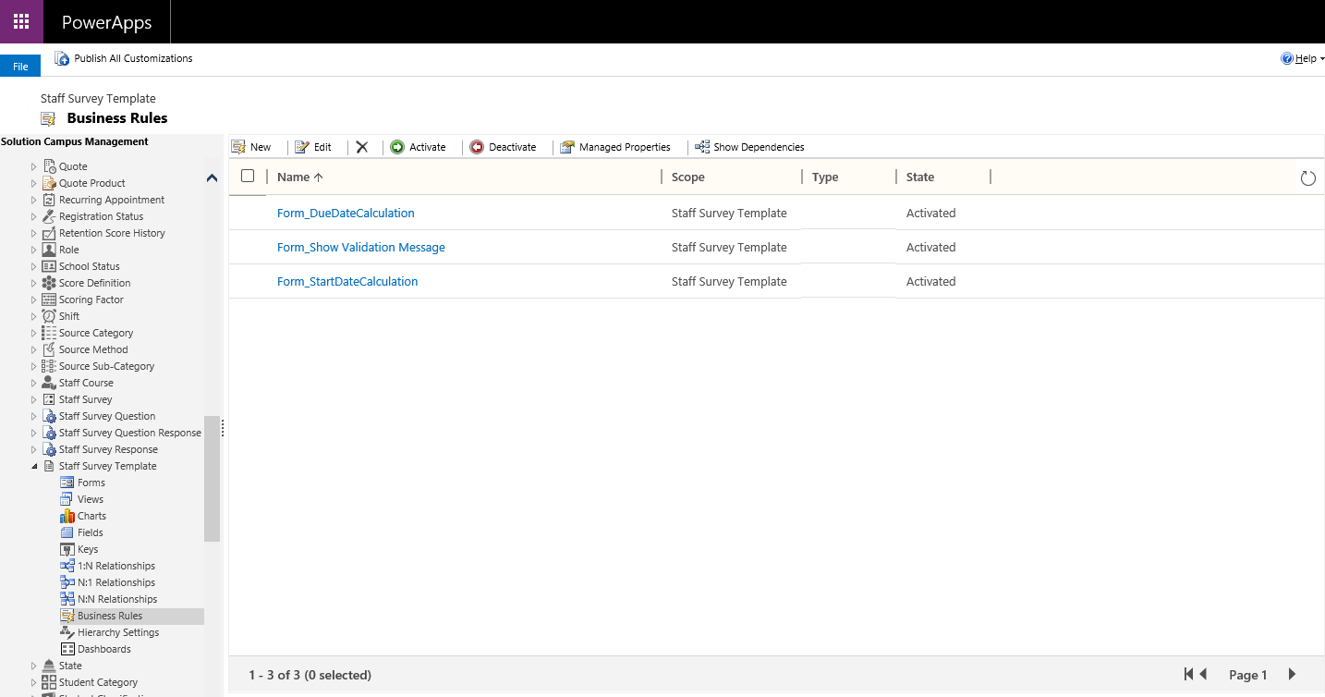

Navigate to Solutions > Campus Management > Entity > Success Plan To Do Template > Business Rules

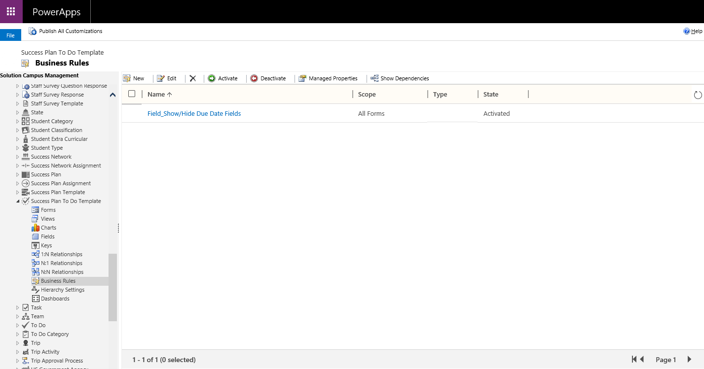

Navigate to Solutions > Campus Management > Entity > Trip > Business Rules

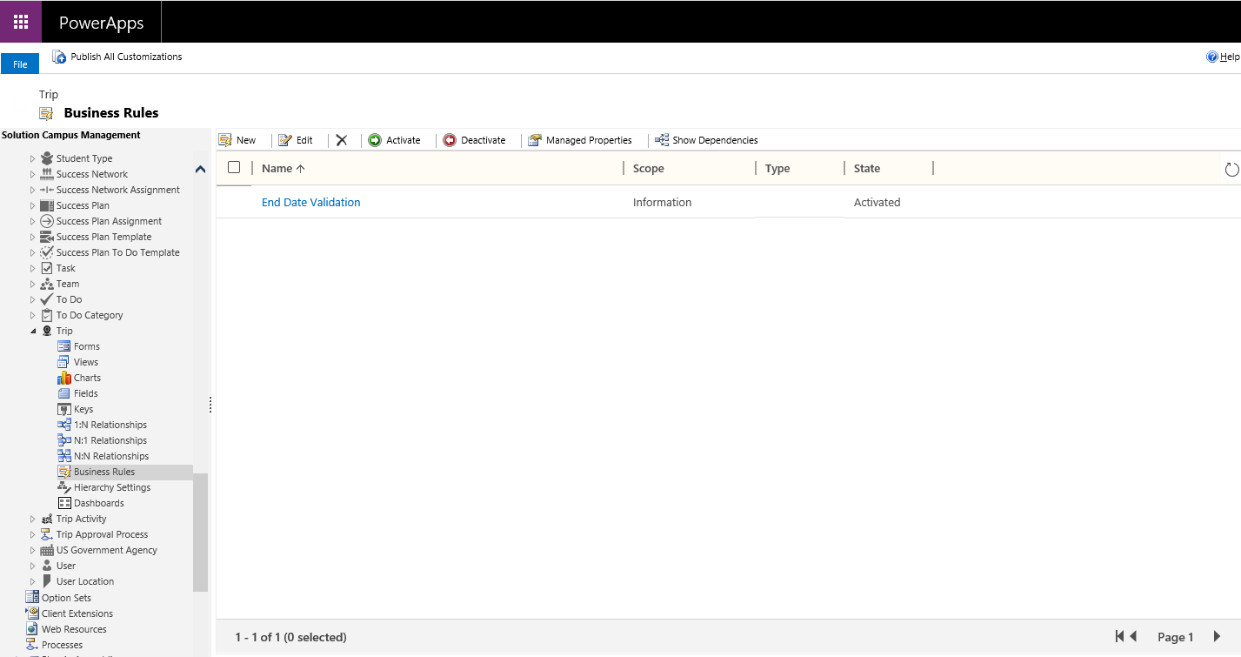

Navigate to Solutions > Campus Management > Entity > Trip Activity > Business Rules

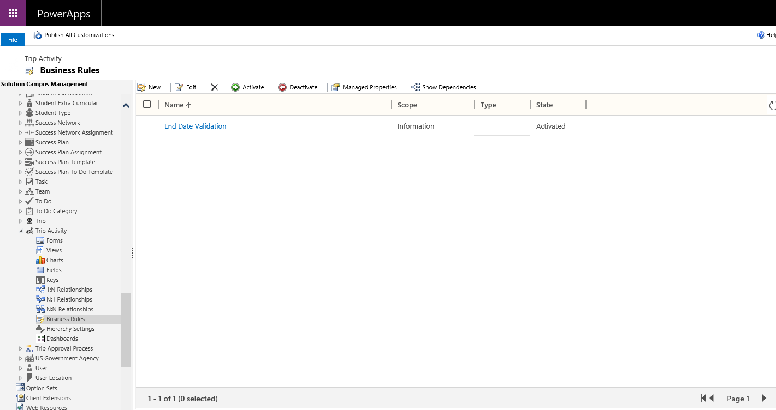

## Actions, Business Process Flows, Custom Workflows

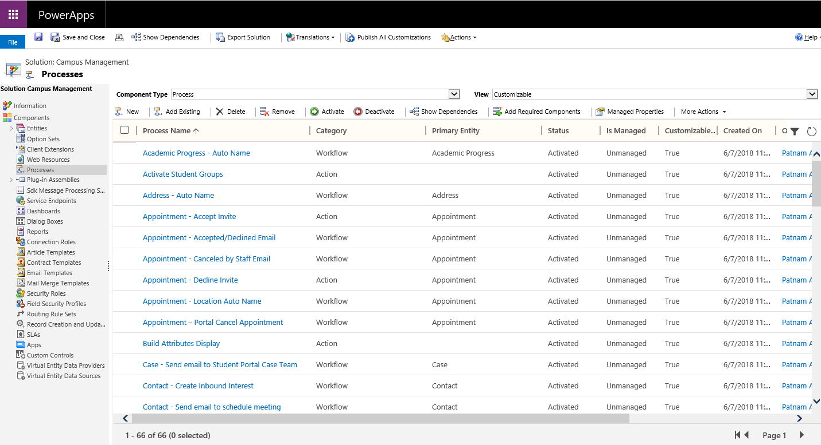

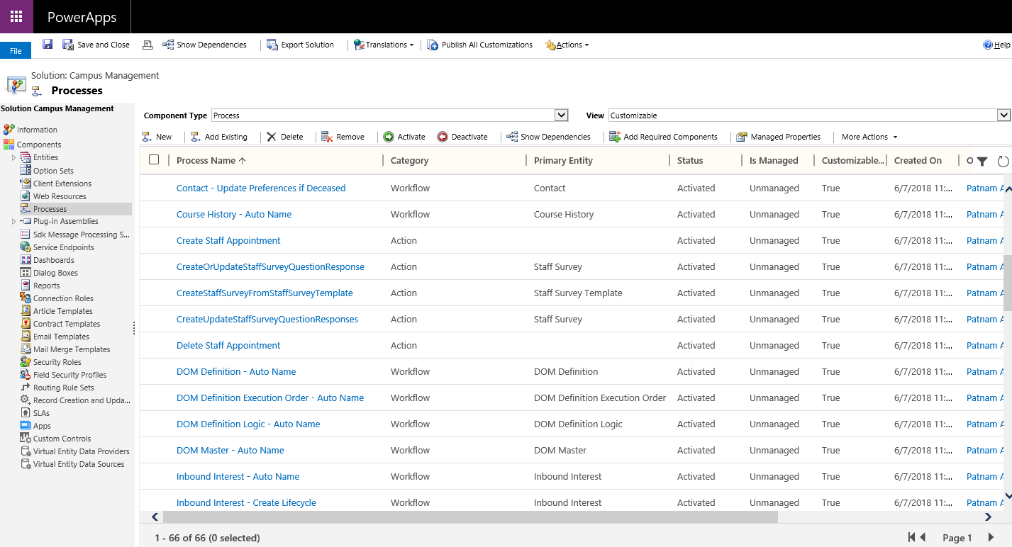

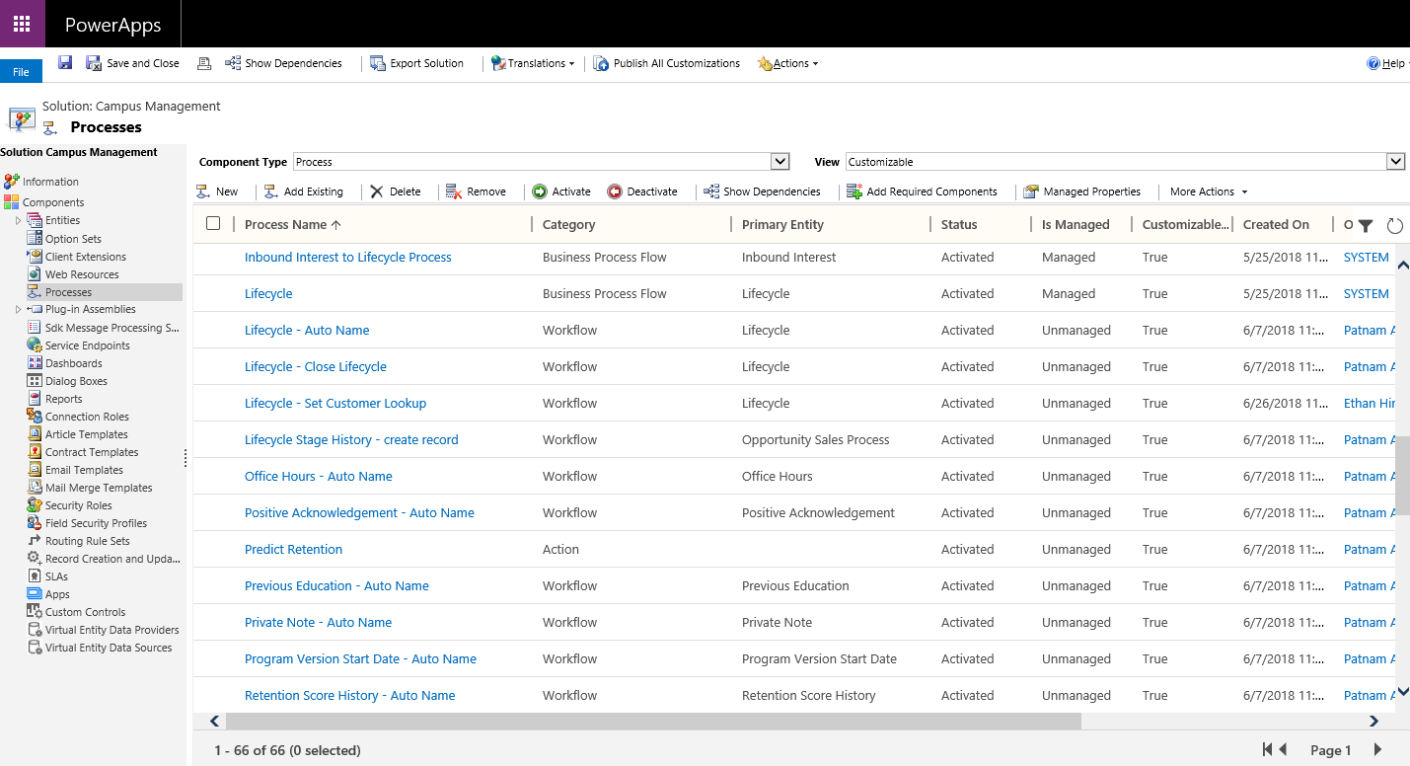

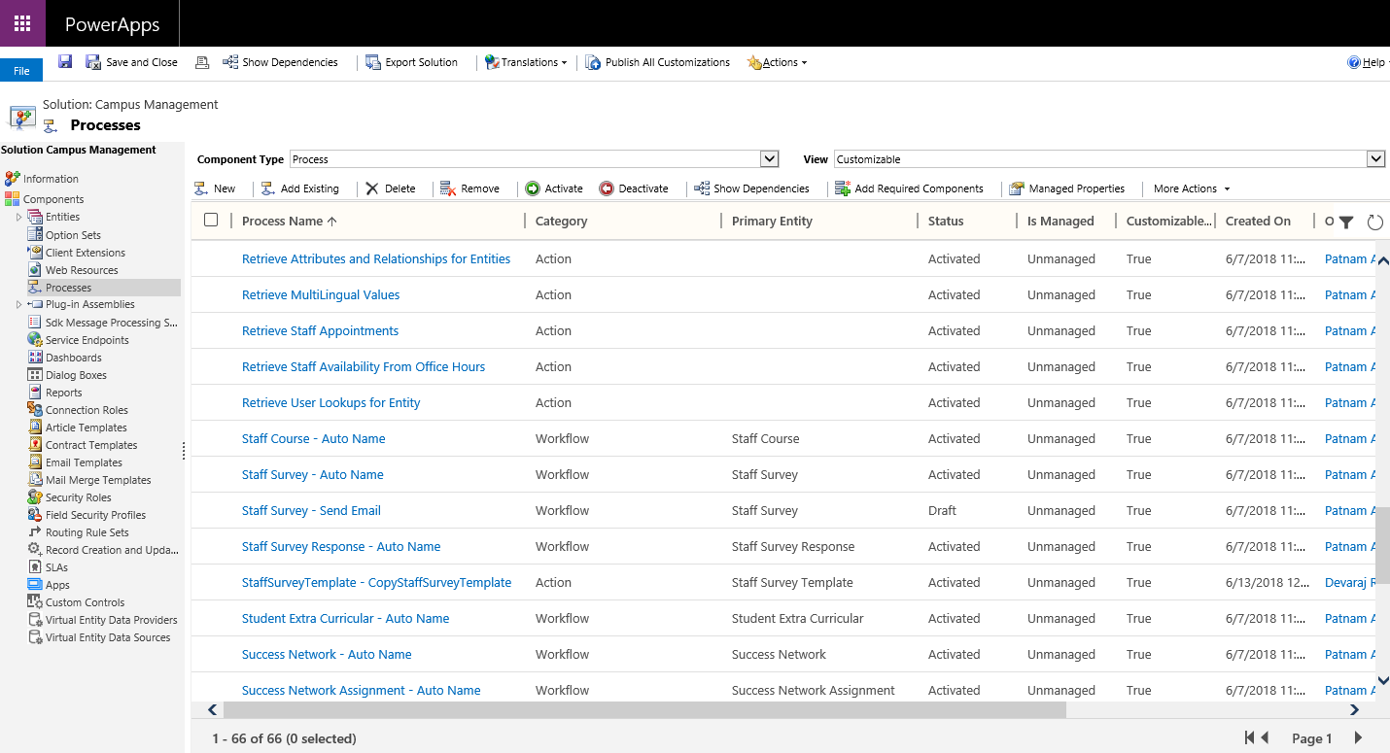

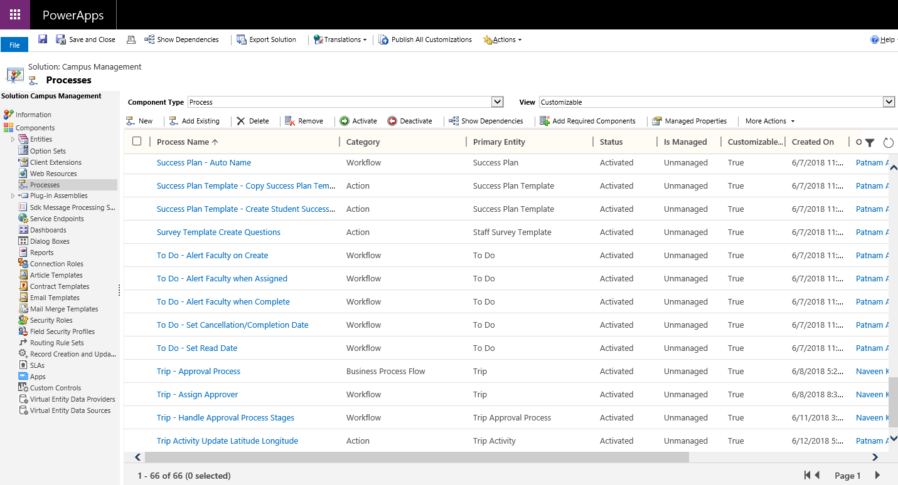



## Portal Configuration

* If the Portal User is already registered, login to Student Portal using the Portal user credentials =>Login should be Successful
* If the Portal User is not registered, follow the steps given under Portal Registration to register:

## Portal Registration

Registering a new user involves creating an External Identity record for a Contact. The instructions will change based on the Identity Provider. The instructions below are based on setting up an Azure User.

1. Create the Contact record. Be sure to set the following fields on the Contact by using the **Portal Contact** form

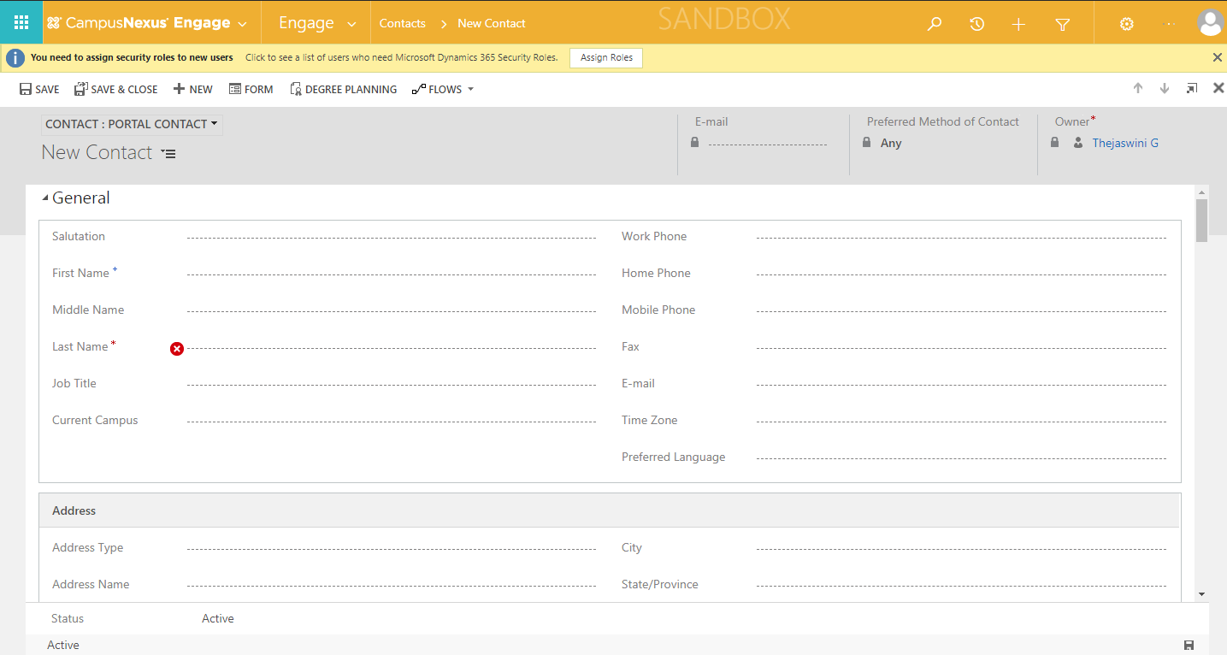

* 1. **Username**: The Id of the User in the Identity Provider system. In Azure, this is the User’s Id.
  2. **Login Enabled**: Checked
  3. **Profile Modified On**: **Today’s Date**

1. Create a new External Identity for the Contact. This will be filled with the following information
   1. **Contact**: The Contact created in step 1.
   2. **Username**: The Id of the User in the Identity Provider system. In Azure, this is the User’s Id.
   3. **Identity Provider**: The token endpoint. For Azure, this is [https://sts.windows.net/Azure ID/](https://sts.windows.net/Azure%20ID/)
      1. **DO NOT LEAVE OUT THE SLASH AT THE END**
2. Run the Workflow “Reset Security Stamp” on the Contact.

## Dashboard

Navigate to Engage > Dashboards > Retention

The following page must be loaded correctly.

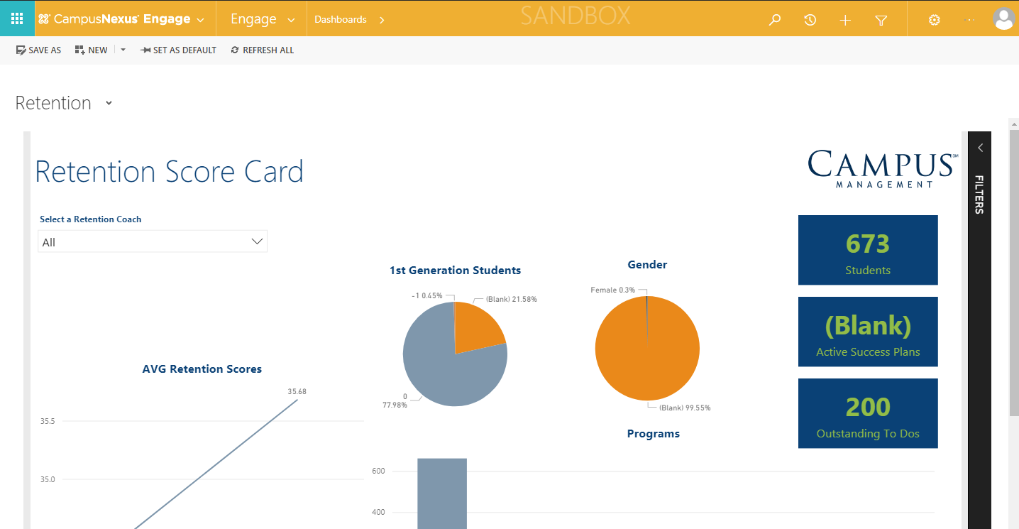

## Verify Azure function settings are correct

* If the Application User is already created:
  + Login to <https://Portal.Azure.com>
  + Navigate to Function Apps > Function App Node > Application Settings
  + The following page must be displayed with the data:

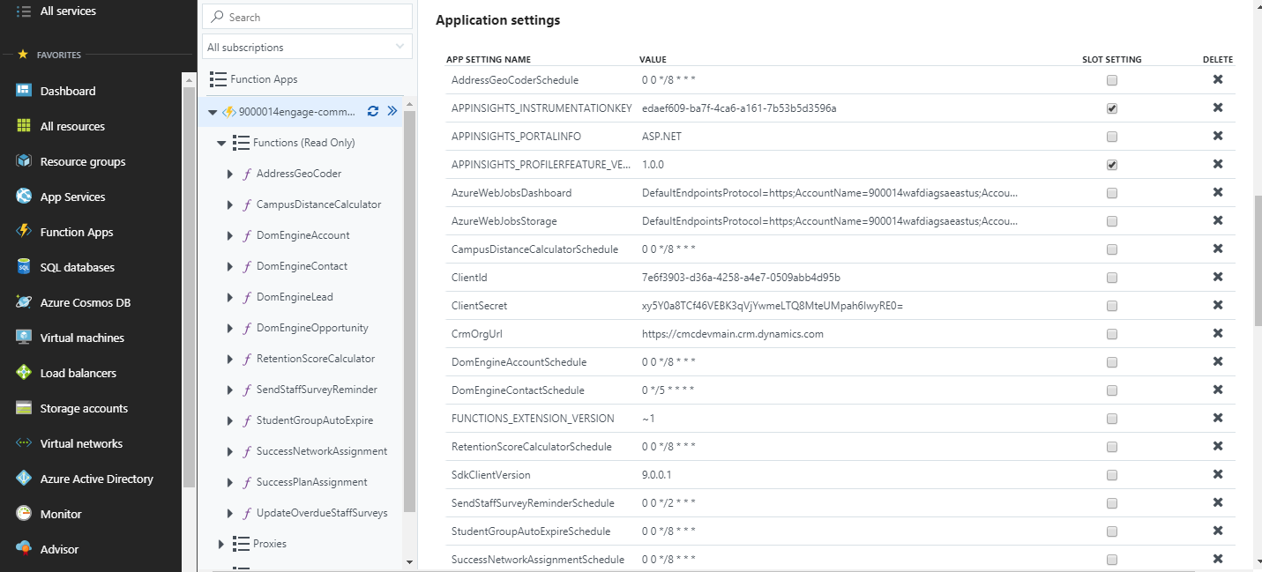

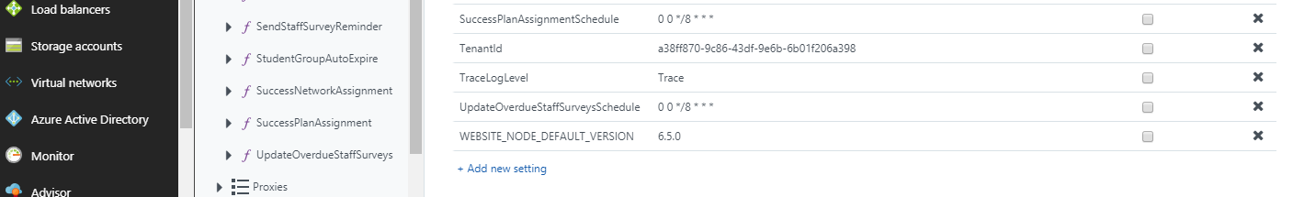

* If the Application User is not created, follow the steps under Creation of Application User to create:

## Creation of Application User

1. In Dynamics Organization, navigate to Settings >Security >Users > Application Users > Create a New User as below

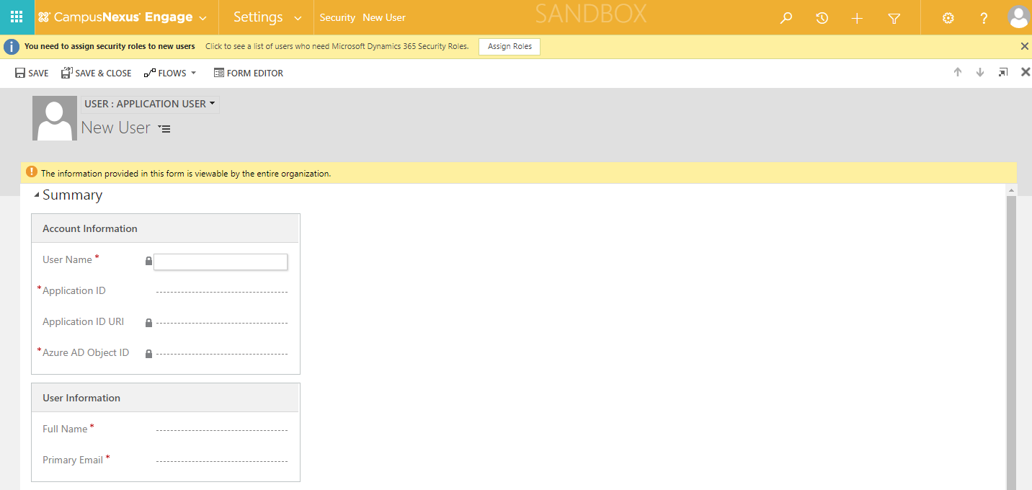

1. Enter the below details and Save:

Application ID

* + Make sure Application is registered with Azure Active Directory. Refer the link for steps on “Application Registration”: <https://docs.microsoft.com/en-us/dynamics365/customer-engagement/developer/walkthrough-register-dynamics-365-app-azure-active-directory>
  + Application ID is available in the below location:
    - Login to <https://portal.azure.com>
    - Navigate to Azure Active Directory > App registrations >Open the App Registered record for the Application and take the Application ID

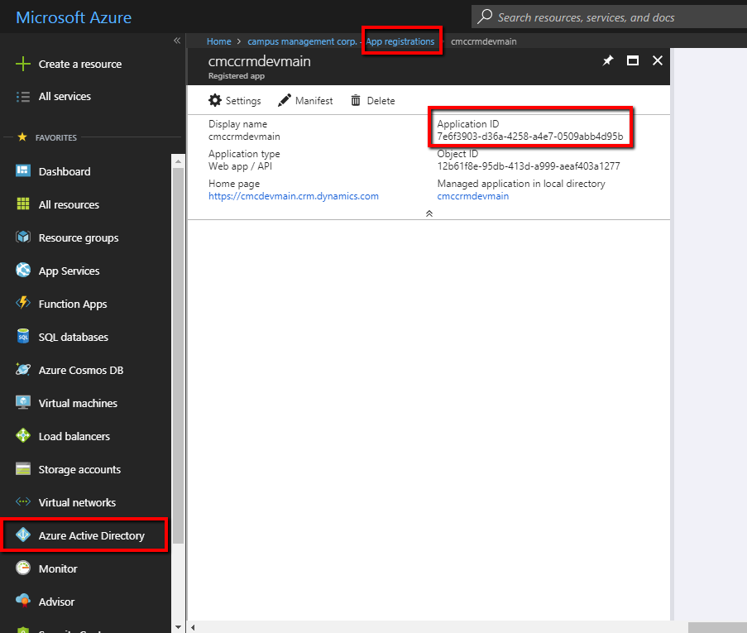

Full Name

Primary Email

1. In the above created Application User Form navigate to Manage Roles >Provide CMC – Azure FunctionApp and System Administrator roles and click on OK

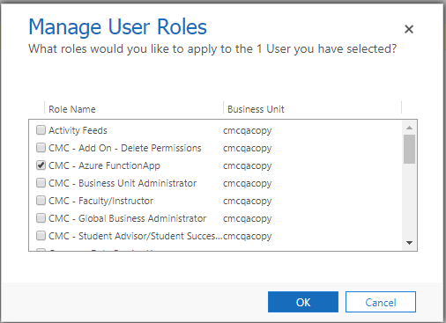

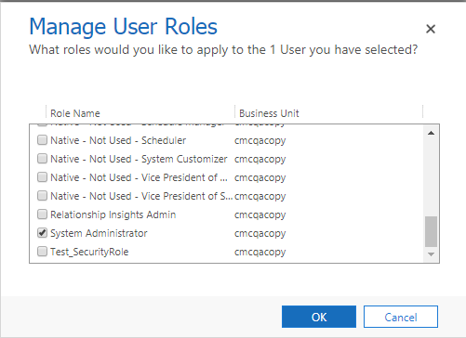

## Verify the Configuration Key settings

Navigate to Settings >Configurations and verify the below configurations are available:

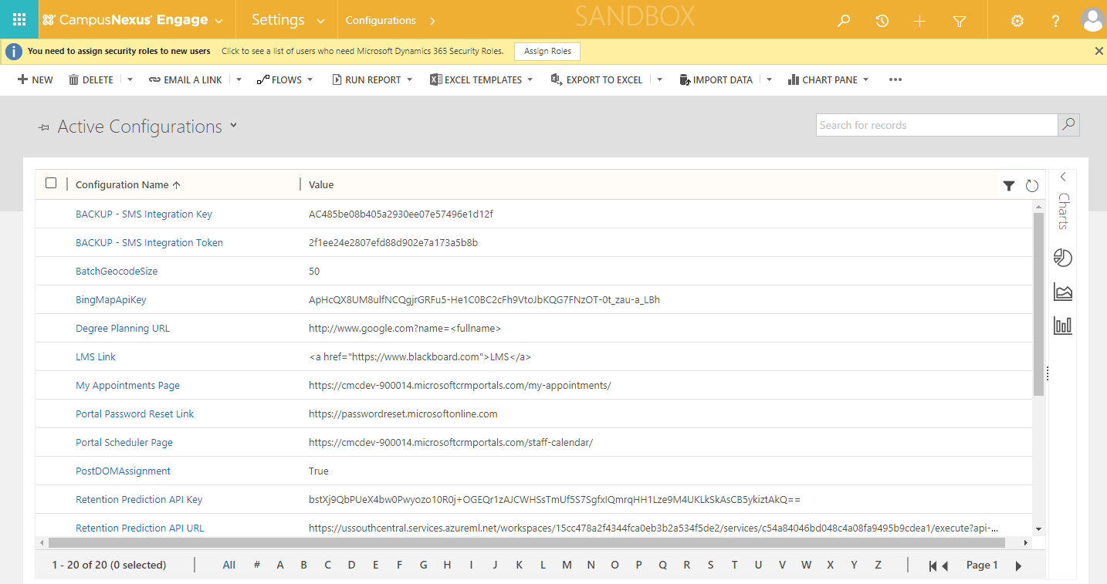

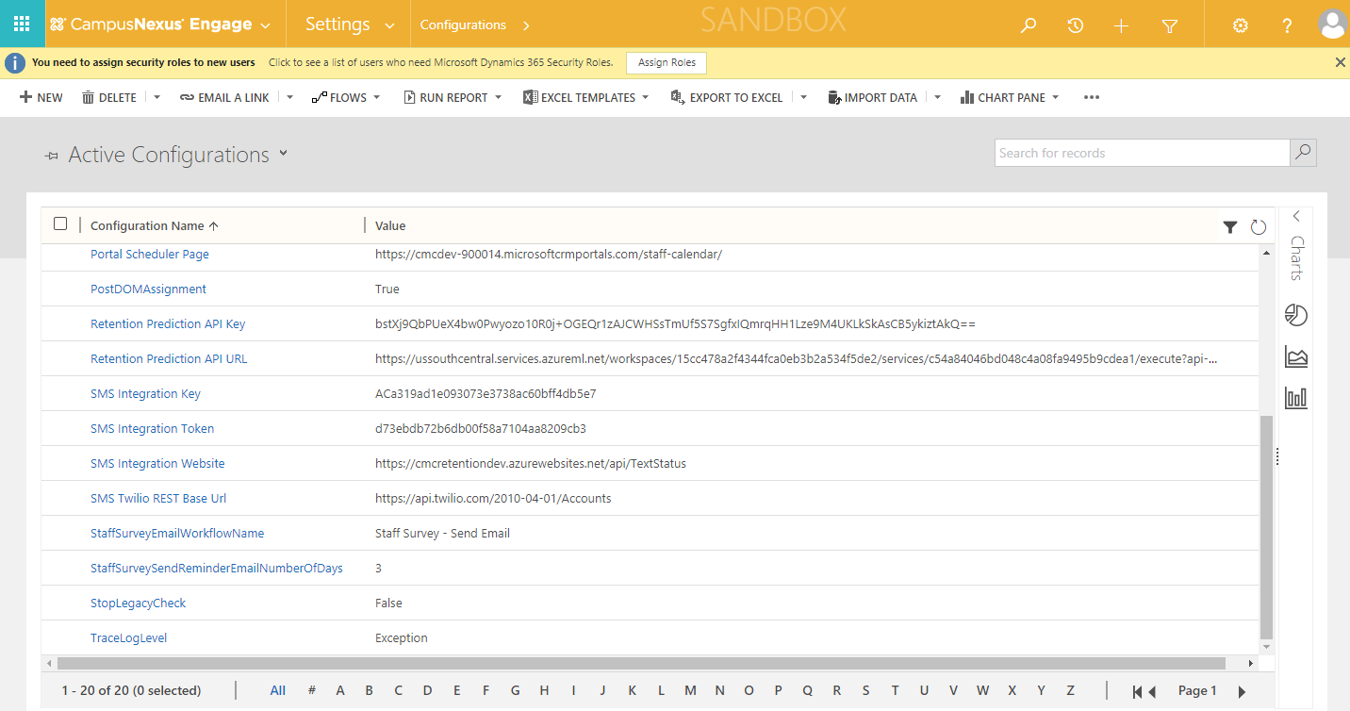

## Ensure TraceLogLevel is set to ‘None’ or ‘Exception’ to avoid performance impact

Navigate to Settings >Configurations > TraceLogLevel and check the Value is set as either None OR Exception as shown below:

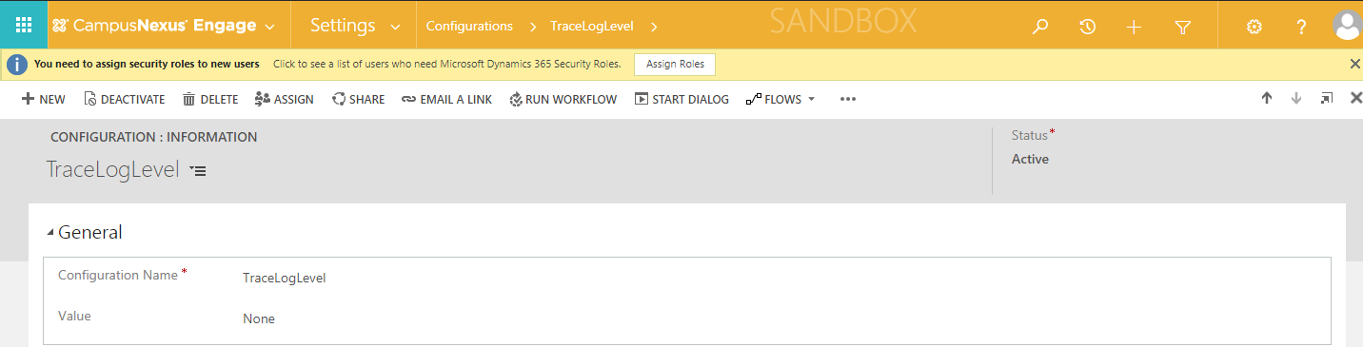

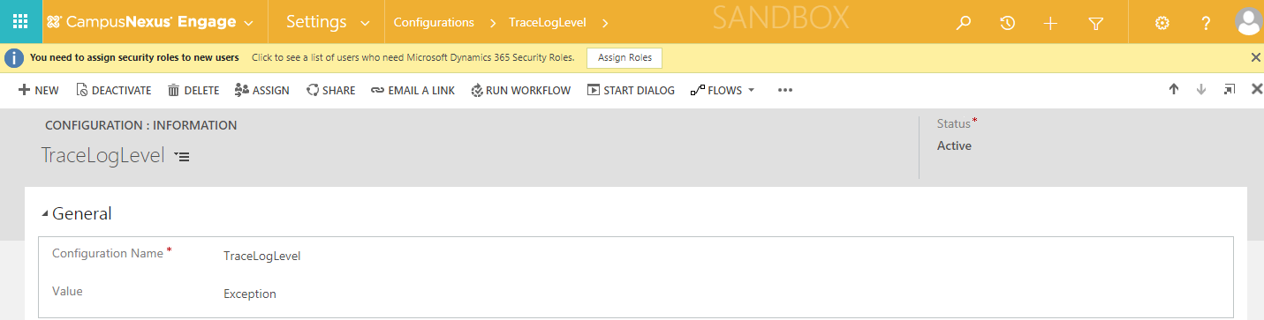

## Ensure Report Scripting Errors Preference is turned off

Navigate to Settings > Administration > Privacy Preferences

Check the **Specify the Web application error notification preferences on behalf of users** and **Automatically send an error report to Microsoft without asking the user for permission** are selectedas below:

